6. Implement program to apply moving average smoothing for data preparation and time series forecasting.
AIM:
Implement program to apply moving average smoothing for data preparation and time series forecasting.
PROCEDURE:
1.Import the necessary libraries:
import numpy as np
import pandas as pd
import matplotlib.pyplot as plt

2. Load the dataset :
file_path = "/content/autism_screening.csv" # Update with actual file path
df = pd.read_csv(file_path)
3.Ensure relevant columns exist.
required_columns = {'age', 'class/asd'}
if not required_columns.issubset(df.columns):
raise ValueError(f"Dataset is missing required columns: {required_columns - set(df.columns)}")
4. Apply Moving Average Smoothing AND Split into train and test sets (80% train, 20% test)
window_size = 5 # Adjust window size as needed
df_agg["Moving_Avg"] = df_agg["class/asd"].rolling(window=window_size, center=True).mean()

split_idx = int(len(df_agg) * 0.8)
train = df_agg.iloc[:split_idx]
test = df_agg.iloc[split_idx:]
5. Forecast using Moving Average
forecast = train["Moving_Avg"].iloc[-window_size:].mean()
test["Forecast"] = forecast # Apply same forecast to all test points

6.Plotting the result:
plt.figure(figsize=(12, 6))

# Original data
plt.plot(df_agg["age"], df_agg["class/asd"], marker="o", linestyle="-", alpha=0.6, label="Original Data")

# Moving Average Smoothed Data
plt.plot(df_agg["age"], df_agg["Moving_Avg"], color="blue", linewidth=2, label="Moving Average Smoothing")

# Forecasted values
plt.plot(test["age"], test["Forecast"], color="red", linestyle="--", linewidth=2, label="Forecast (Moving Avg)")

# Labels & legend
plt.xlabel("Age")
plt.ylabel("Mean ASD Score")
plt.title("Moving Average Smoothing & Forecasting")
plt.legend()
plt.grid(True)

# Show plot
plt.show()

OUTPUT
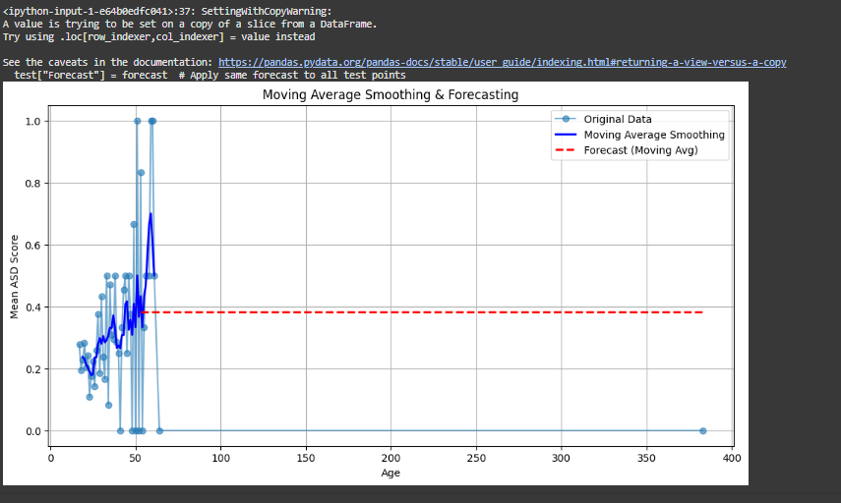

RESULT:
The program to implement to apply moving average smoothing on the autism screening dataset has been implemented successfully.

